**CST-305: Project 1 – Visualize ODE With SciPy**

Nathan Dilla, Caleb Klinger

College of Science, Technology and Engineering, Grand Canyon University

CST-305: Modeling and Simulation

Professor Ricardo Citro

September 17, 2023

**Responsibilities and Tasks**

| Nathan Dilla | * Research differential equations * Solve differential equation using python * Write responsibilities and tasks * Format document |
| --- | --- |
| Caleb Klinger | * Research differential equations * Solve differential equation using python * Create git repository * Md file |

**Context**

Network bandwidth is how much a network can transmit data over time. It is a crucial performance metric for a computer network. Network bandwidth can be measured in the rate of change of how many data packets are in and out of the network as it directly shows how much data can be sent or received. A differential equation can be used to describe this dynamic system:

$\frac{dP}{dt}= I(t)-O(t)$

$\frac{dP}{dt}$ is the rate of change of data packets in the network.

$I(t)$ is the rate of data packets entering the network at time *t.*

$O(t)$ is the rate of data packets leaving the network at time *t.*

**Problem Solved**

Problem Statement: How can we solve and visualize the network bandwidth over time to solve the ODE.

We need to determine and visualize the rate of network bandwidth over time based on the differential equation $\frac{dP}{dt}= I(t)-O(t)$

The solution we created to this problem is the code we created. This code takes in a rate of change of network bandwidth as input, solves the differential equation representing the dynamics of the network bandwidth, and then visualizes the solution over time.

**Mathematical Approach**

The differential equation given is: $\frac{dP}{dt}= I(t)-O(t)$ Where:

* $\frac{dP}{dt}$ is the rate of change of data packets in the network.
* $I(t)$ is the rate of data packets entering the network at time tt.
* $O(t)$ is the rate of data packets leaving the network at time tt.

This equation describes the net rate of data packets in the network at any given time tt. If I(t) is greater than O(t), the network is accumulating data packets. Conversely, if O(t) is greater than I(t), the network is losing data packets.

In the code, the differential equation are simplified. Instead of having separate functions for I(t) and O(t), the user provides a constant rate, which is the difference between I(t) and O(t). This means that the net rate of data packets entering or leaving the network is assumed to be constant over time.

The simplified differential equation in the code is:

$\frac{dy}{dt}= rate - y$

Where:

y is the current rate of data packets in the network.

rate is the constant rate of change of network bandwidth provided by the user.

The differential equation is a first-order ordinary differential equation (ODE). It can be solved using various methods, but in the code, the odeint function from the scipy.integrate module is used. This function numerically integrates the differential equation to provide a solution over a specified range of time points. Once the ODE is solved, the solution represents the rate of network bandwidth over time. Plotting this solution against time provides a visual representation of how the network bandwidth changes over the specified time interval. This visualization is crucial for understanding the behavior of the network and making informed decisions about network management and optimization.

**Implementation**

Importing Necessary Libraries:

The code begins by importing essential libraries:

numpy for numerical operations and generating arrays.

odeint from scipy.integrate for solving the differential equation.

matplotlib.pyplot for plotting the results.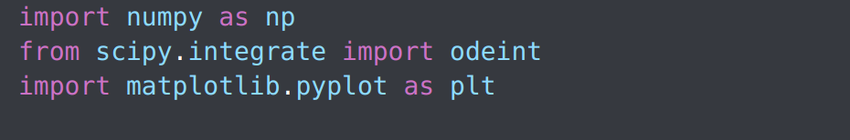

Defining the Differential Equation:

The function network_bandwidth is defined to represent the differential equation. It takes in the current rate of data packets in the network (y), the current time (t), and the rate of change of network bandwidth (rate). It returns the difference between the rate and the current rate of data packets.



User Input:

The user is prompted to provide the rate of change of network bandwidth. This input is stored in the variable rate.



Setting Up Time Points:

An array of time points, t, is generated using numpy's linspace function. This array spans from 0 to 60 seconds and contains 100 points. These time points will be used for solving the differential equation. The initial condition, y0, is set to 0. This means that at the start (time = 0), the rate of data packets in the network is 0.

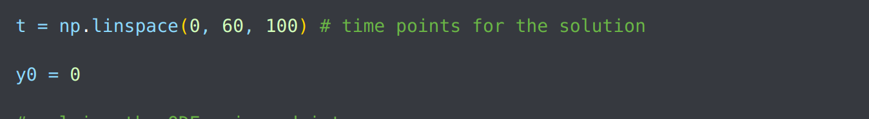

Solving the Differential Equation:

The odeint function is used to solve the differential equation. It takes in the differential equation function (network_bandwidth), the initial condition (y0), the time points (t), and any additional arguments required by the differential equation function (in this case, rate).

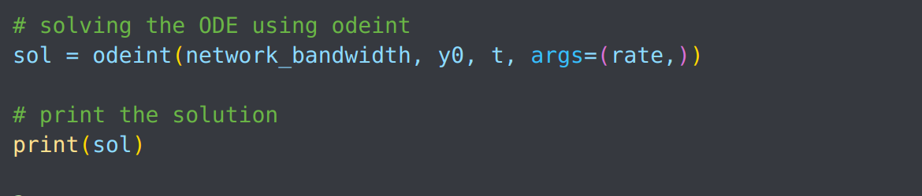

Visualization:

The solution, sol, is plotted against the time points, t, using matplotlib. The plot is labeled appropriately to provide context.

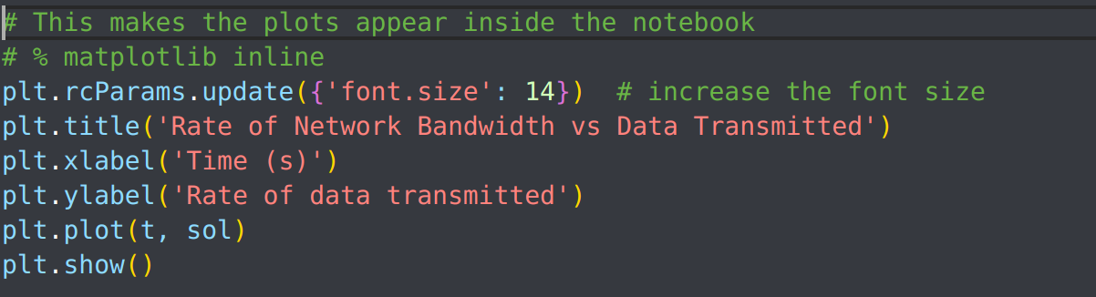

Visual results for a user input of 3

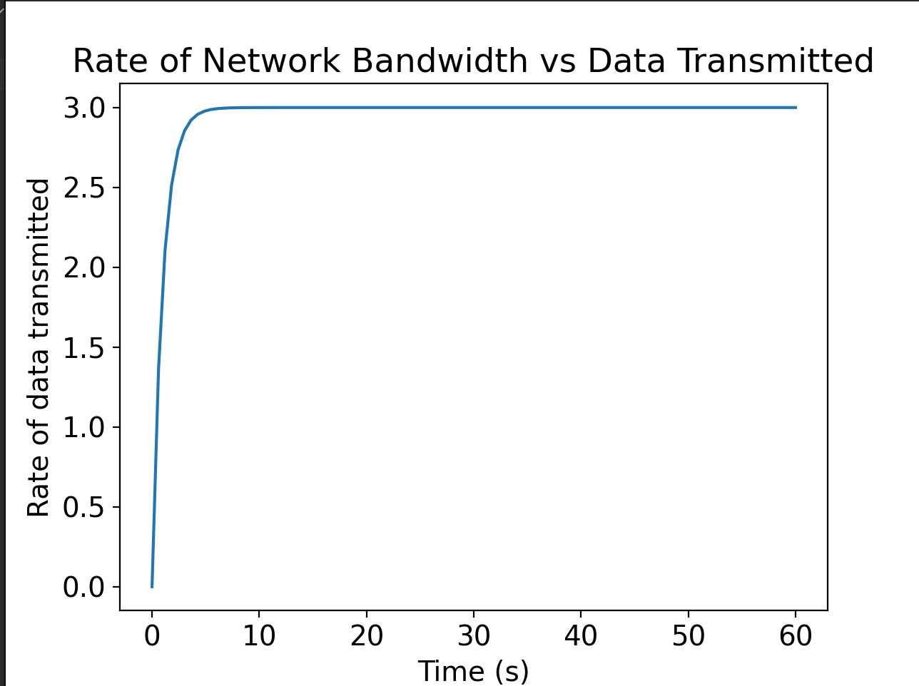

**References**

<https://blogs.cornell.edu/info2040/2017/09/13/visualizing-odes-as-networks-the-development-of-tygers-from-burgers-equation-solved-using-spectral-methods/>

**Code:**https://github.com/TrippingLettuce/Principles-of-Modeling-and-Simulation